pony club logo

**MORPETH HUNT PONY CLUB**

**WILD FLOWERS ACHIEVEMENT BADGE**

Identify the flowers shown below and complete the Wordsearch

Name : ________________________________________________________________

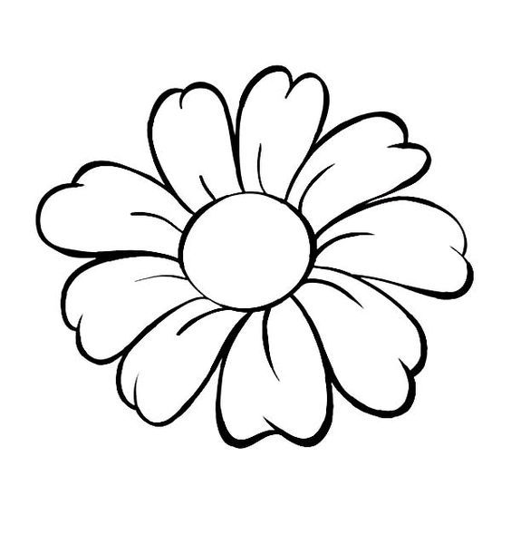

 

__________________________________

__________________________________



__________________________________

__________________________________

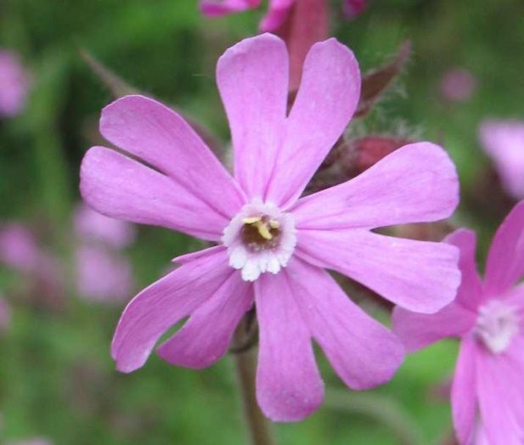



__________________________________

__________________________________





______________________________

______________________________



______________________________

______________________________



______________________________

______________________________

**WORDSEARCH**

**find the following …..**

Bluebell Buttercup Clover Cowslip Daisy Dandelion Forget-me-not Foxglove Heather

Nightshade Poppy Primrose Ragwort Red Campion Snowdrop

Thistle Violet White Campion

