pony club logo

**MORPETH HUNT PONY CLUB**

**Mini Achievement Badge**

**Poisonous Plants**

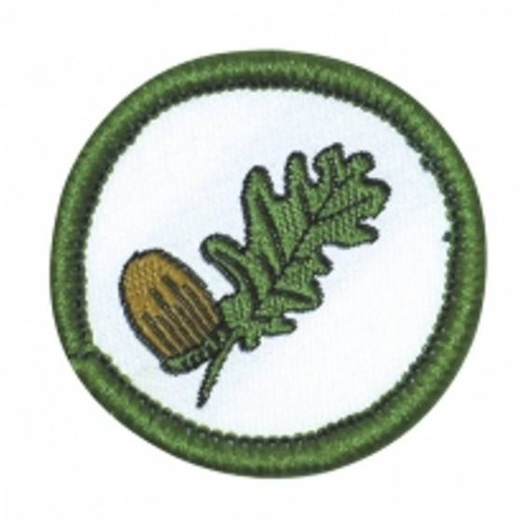

Name : ________________________________________________________________

Identify the following plants

Deadly Nightshade • Foxglove • Hemlock • Ragwort • Acorn



__________________________________

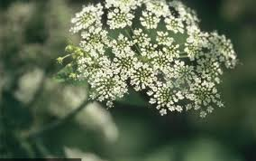

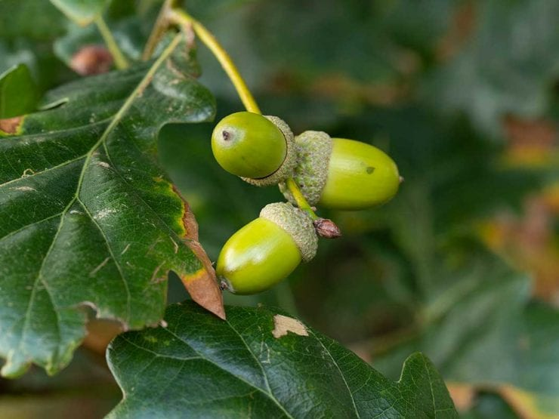

__________________________________

__________________________________

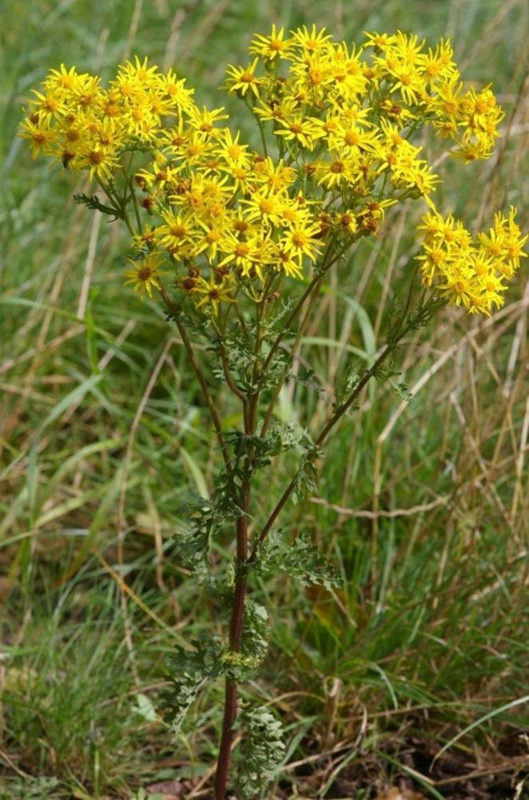

__________________________________

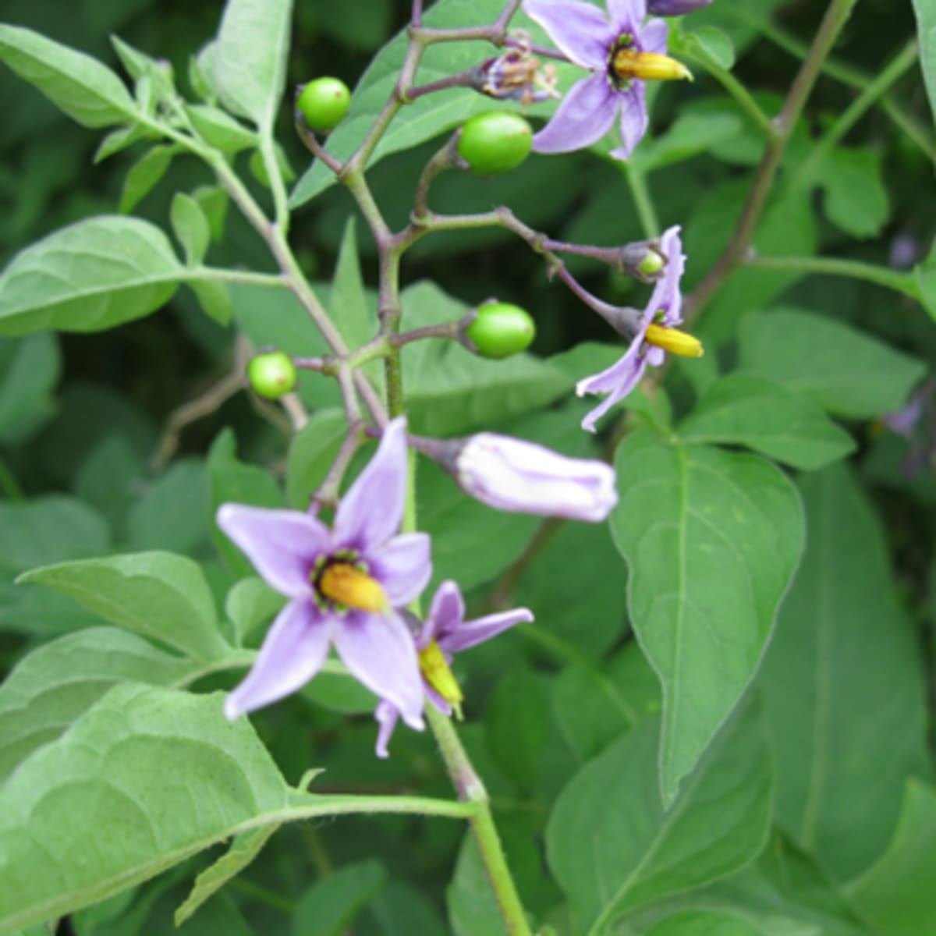

__________________________________

**WORDSEARCH**

**find the following …..**

Deadly Nightshade • Foxglove • Hemlock • Ragwort • Acorn

|  |  |  |  |  |  |  |  |  |  |  |  |  |  |  |  |
| --- | --- | --- | --- | --- | --- | --- | --- | --- | --- | --- | --- | --- | --- | --- | --- |
| D | E | A | D | L | Y | N | I | G | H | T | S | H | A | D | E |
| O | E | C | T | I | E | M | C | V | E | V | I | N | R | E | B |
| C | O | O | Y | U | W | N | X | B | M | K | P | L | M | G | Y |
| K | W | R | A | G | W | O | R | T | L | F | O | X | G | L | U |
| V | I | N | R | E | A | W | S | F | O | A | C | O | R | N | M |
| K | P | L | M | G | J | R | D | S | C | C | T | I | E | M | D |
| F | O | X | G | L | O | V | E | Z | K | O | Y | U | W | N | V |

Colour in the

