Butterflies and Moths Achievement Badge

What's the difference between a butterfly and a moth? Is it just a matter of
looks? Take our Quiz and learn more about butterflies, moths and the
differences between them.

Q1: How many pairs of wings do butterflies and moths have?
2 pairs 3 pairs 4 pairs 5 pairs

Q2: How many species of moths and butterflies are there in the UK (approx)?
a) 10 moths/5 butterflies
b) 100 moths/5 butterflies
c) 500 moths/10 butterflies
d) 2,500 moths/60 butterflies

Q3: When are butterflies most active?
During the day At dusk Middle of the night Early morning

Q4: Which has the more slender body?
Moths Butterflies Caterpillars

Q5: What order do moths and butterflies belong to?
Hemiptera Coleoptera Diptera Lepidoptera

Q6: How wide are the Blue Morpho butterfly's wings?
2 in (5 cm) 3 in (8 cm) 5 in (13 cm) 6 in (15cm)

Q7: What colour are the Esmeralda butterfly's wings?
Transparent Emerald green Ruby red Violet

Q8: What colour are African Cymotho butterflies?
Red Green Blue Yellow

Q9: How many inches wide are the world’s largest butterfly’s wings?
5 in (13 cm) 8 in (20 cm) 10 in (25 cm) 12 in (30 cm)

Q10: What is Europe's most unusual butterfly?
The Peacock The Hammer The Wood Nymph The Common Blue

Q11: At which stage of development are butterflies and moths pests?
Egg Adulthood Pupa Larva

Q12: Which type of moth has been domesticated?
Silkworm Moth Honeybee Moth Hummingbird Moth Cinnabar Moth

Q13: Which plant should be used to attract Swallowtail butterflies?
Sunflower Plants Parsley Plants Mint Plants Thyme Plants

Q14: How many species of butterflies are in danger of extinction?
10 20 30 40

Q15: Which of the butterfly and moth's five senses is most sensitive?
Smell Hearing Taste Sight

Q16: What do moths and butterflies use their legs for?
Crawling Takeoff Jumping Running

Q17: Which butterfly has eyespots that may be used to scare away predators?
Monarch Common Buckeye Giant Swallowtail Painted Lady

Q18: How long does it take for a Monarch to grow from an egg to an adult butterfly?
One day One week One month One year

Q19: Butterflies live everywhere except which continent?
Antarctica South America Africa Europe

Q20: Which body part do butterflies use for taste?
Wings Feet Antenna Abdomen

Q21: Which of the following lists the correct order for a butterfly’s life cycle?
a) Egg, caterpillar, chrysalis, adult
b) Chrysalis, egg, caterpillar, adult
c) Caterpillar, chrysalis, egg, adult
d) Adult, caterpillar, chrysalis, egg

Butterfly - Life Cycle Diagram

Butterflies undergo complete metamorphosis. The larva (caterpillar) hatches from an egg that the female usually lays on the underside of leaves. After growing, it enters the pupal phase during which it forms a protective chrysalis and metamorphoses into a winged insect - the adult butterfly. After mating, the female lays eggs and the cycle begins again.

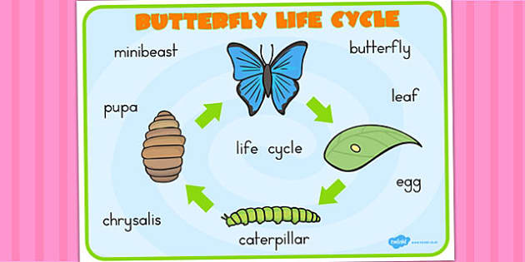

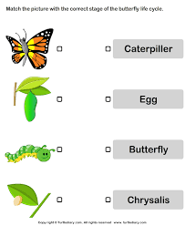

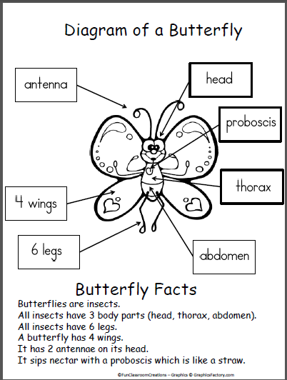
Label the diagram below with the body parts

