Morpeth Hunt Pony Club
Mini Hunter Trial
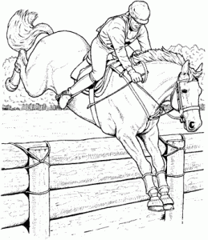
Friday 1st November 2024
To be held at Thornton Moor Farm, NE61 4JG
By kind permission of Mr & Mrs Stafford

The competition is open to all our members and will be a fun and relaxed event.

Classes:

- Lead rein, jumps will be very small
- Jumps not to exceed 35cm (can have assistance)
- Jumps not to exceed 50cm
- Jumps not to exceed 60cm
- Jumps not to exceed 70cm
- Jumps not to exceed 80cm

The XC for all classes will be over working hunter jumps set up in the field

All classes £10
Rosettes to 6th place.
Entries close 28th October

Entries via Horse Events https://www.horse-events.co.uk/horse-events/morpeth-hunt-pony-club-mini-halloween-hunter-trial-friday-1st-november-20241101

Rules
- To be run under PC rules
- All competitors must wear a BS riding hat to current specifications whilst mounted.
- Body protectors must be worn for jumping
- The organisers or any persons acting on their behalf do not accept any liability for any loss, damage, accident, injury to horses, ponies, riders, spectators or property whatsoever in connection with or arising from this event.
- Dogs, must be kept on a lead at all times.
- Save for the death or personal injury caused by the negligence of the organisers, or
anyone for whom they are in law responsible, neither the organisers of this event or
The Pony Club nor any agent, employee or representative of these bodies, nor the
landlord or his tenant, accepts any liability for any accident, loss, damage, injury or
illness to horses, owners, riders, spectators, land, cars, their contents and accessories,
or any other personal property whatsoever, whether caused by their negligence,
breach of contract or in any other way whatsoever. Entries are only accepted on this
basis.
- The organisers of this event have taken all reasonable precautions to ensure the
health and safety of everyone present at this event. For these measures to be
effective, everyone must take all reasonable precautions to avoid and prevent
accidents. They must obey the instructions of the organisers and all officials and
stewards.

Times for each class will be posted on our website www.MorpethHuntPC.co.uk

All enquiries to
Michelle Macaulay,
DC@morpethhuntpc.co.uk

