Morpeth Hunt PC Halloween Show jumping

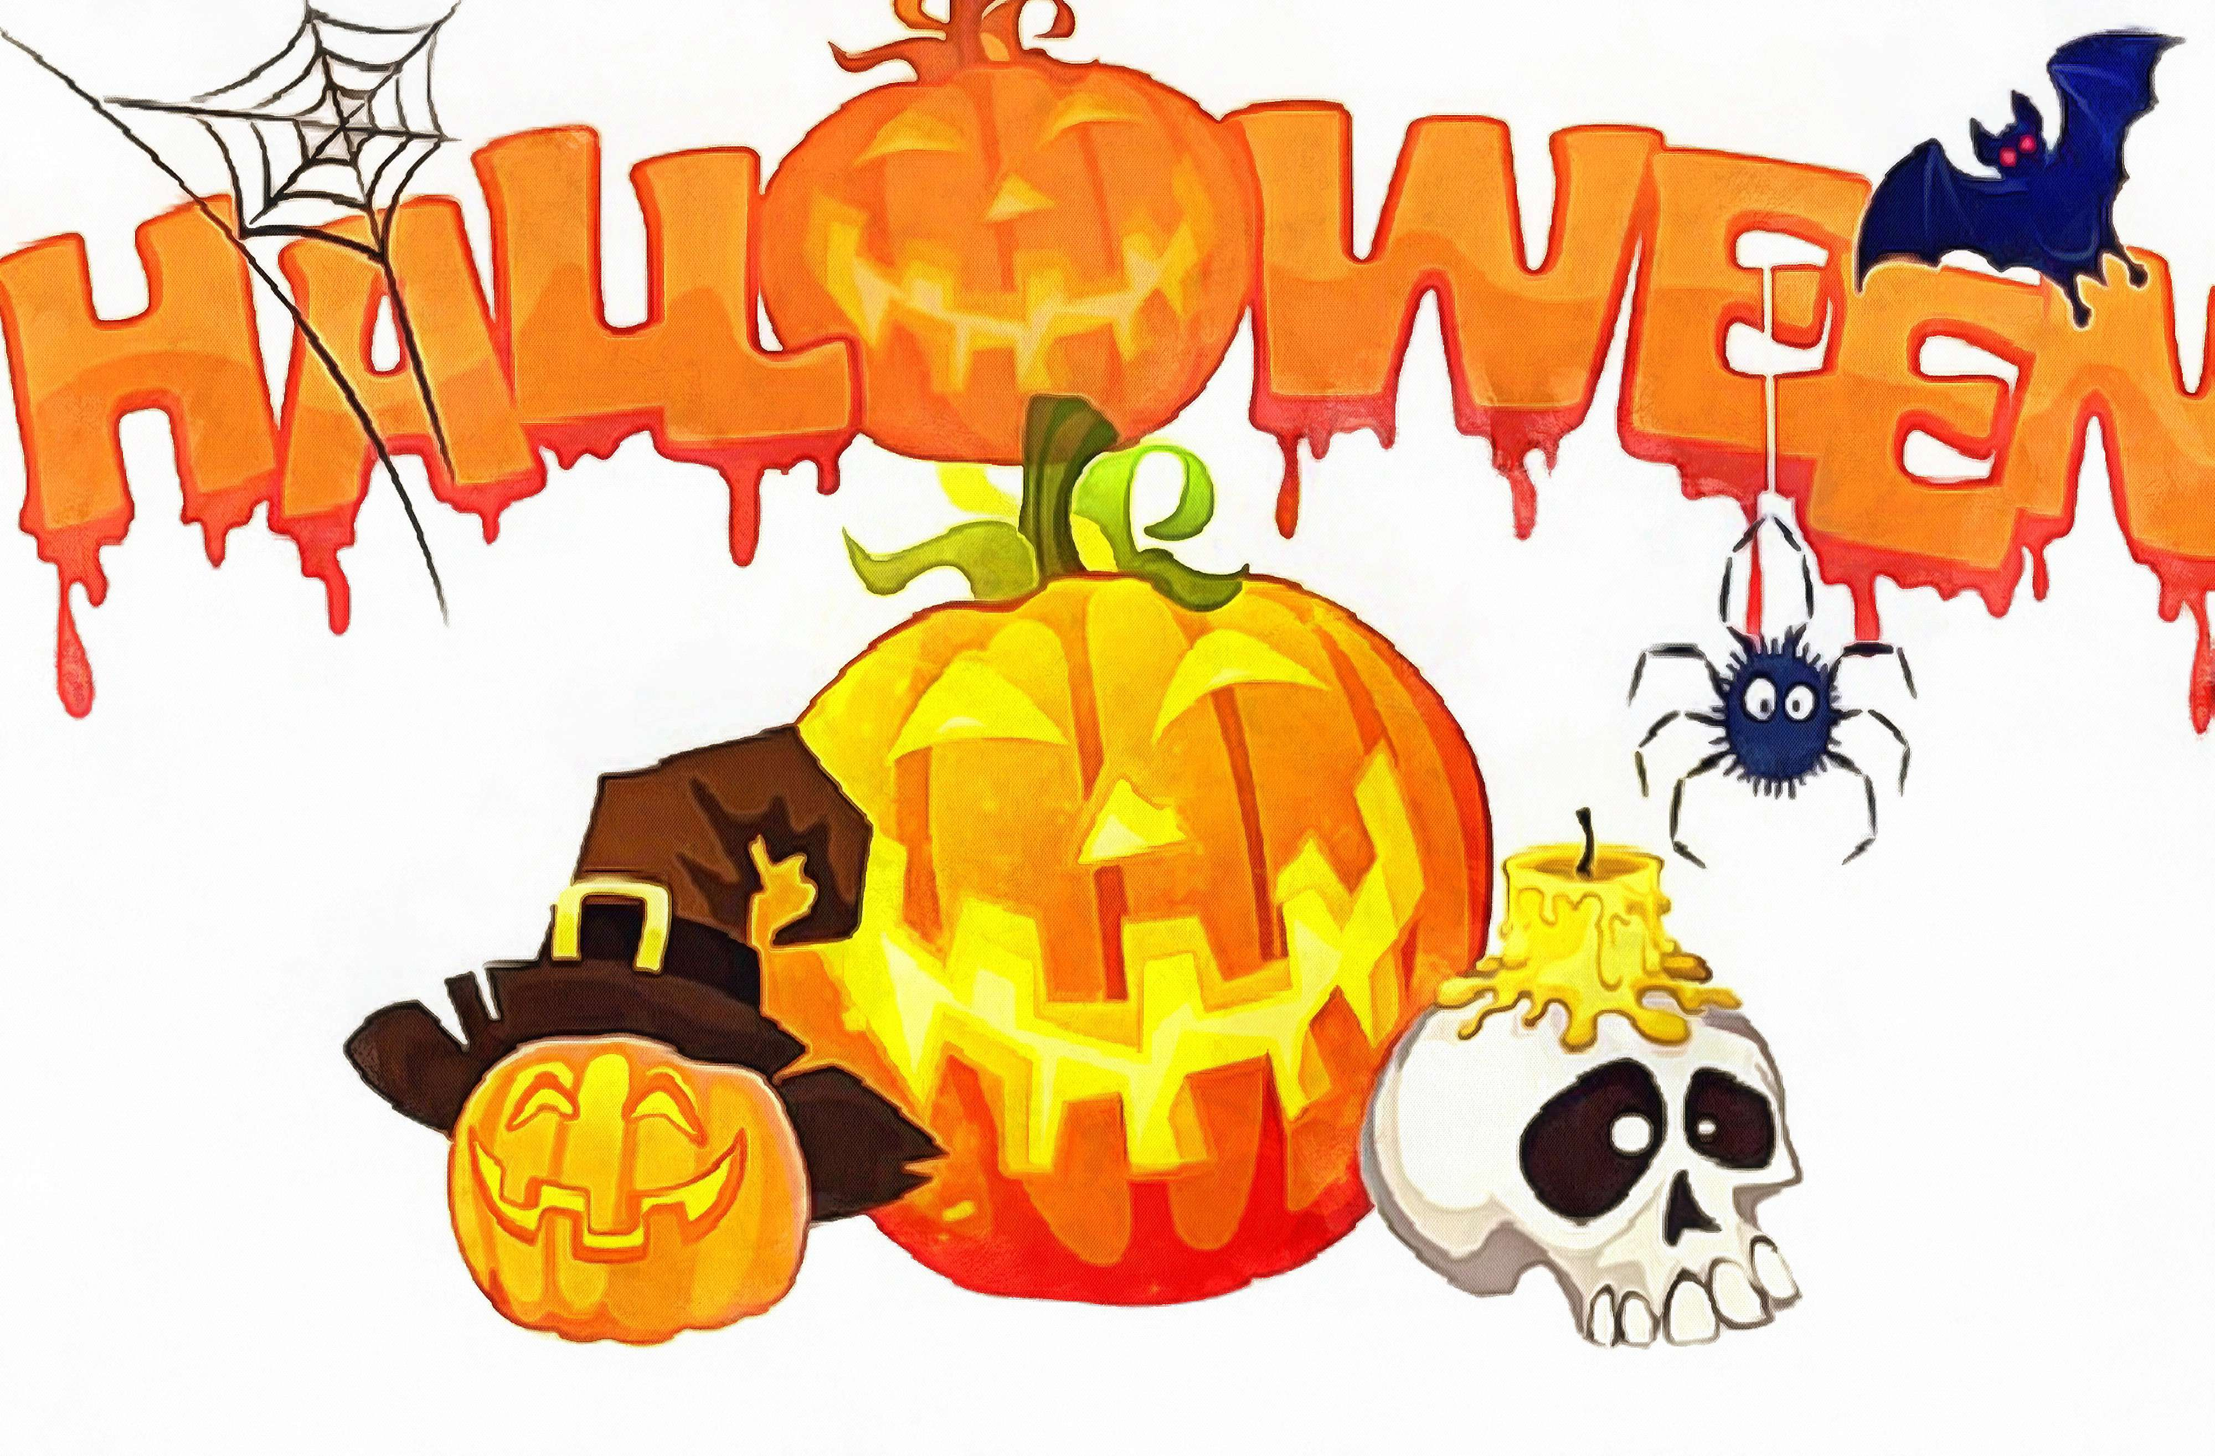

Friday 31st October
To be held at Houndalee Farm, Widdrington, NE61 5EE
Starting at 11am

Classes
- Little Witches Lead Rein, jumps will be very small
- Monster Minis, LR / assisted, jumps not to exceed 40cm
- Pumpkin Pairs for competitors who have competed in classes 1 or 2
- Cauldron Cracker, jumps not to exceed 50cm
- Broomstick Stakes, jumps not to exceed 60cm
- Poltergeist Pairs for competitors who have competed in classes 4 or 5
- Ghostly Surprise, jumps not to exceed 70cm
- Spooky Stakes, jumps not to exceed 80cm
- Prankster Pairs for competitors who have competed in classes 7 or 8

All classes £10, pairs £10 per pair. Rosettes to 6th place

Entries to be made through Horse Events
Entries close on 24th October

Rules
- Open to all (non PC members welcome)
- To be run under PC rules
- All competitors must wear a BS riding hat whilst mounted.
- The organisers or any persons acting on their behalf do not accept any liability for any loss, damage, accident, injury to horses, ponies, riders, spectators or property whatsoever in connection with or arising from this event.
- Dogs must be kept on a lead at all times.
- No skipping out on the field anyone found doing so will incur a £10 fine.
- The judges’ decision is final. Any objections / complaints must be lodged in writing to the secretary with a deposit of £20 (returnable if the objection / complaint is upheld).
- We recommend that body protectors are worn for all classes.
- Litter must be taken home.
- Entries close on 24th October

Approx times for each class will be posted on our website
All queries please contact DC@morpethhuntpc.co.uk

