2015 Championships
Yet again our branch had a very successful Championships.
National Championships at Cholmondley Castle
Both our junior and senior games teams went to The Championships and produced some fantastic results.
The senior team of Harri Baker, Tillie Ball, Ellie Forster, Lucy Pittendrigh & Lucy Walby won the intermediate competition and came 2nd in tack & turnout . In the junior competition our junior team of Max Kirby, Hannah-Jane Lunny, Charlie Parker, Jessica Robinson & Eloise Woods came 5th and won the tack & turnout. Thanks to our team trainers, Vicki Dungait and Charlotte Robson, for all their hard work and commitment to the teams.
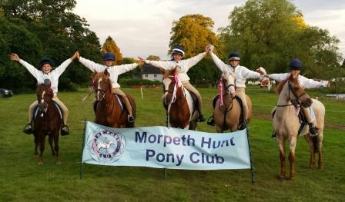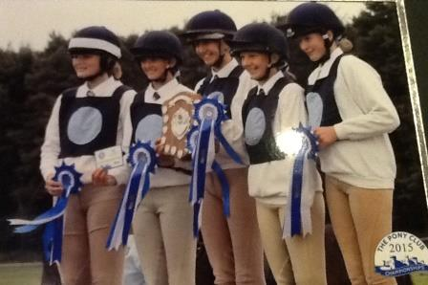
One of our older members, Ewan Macaulay, was presented as a PC Ambassador at the Championships. His role will involve working at a National as well as a local level in various PC disciplines & activities. As part of this Ewan will be setting up an official MHPC Facebook page as well as helping to co-ordinate a junior committee.

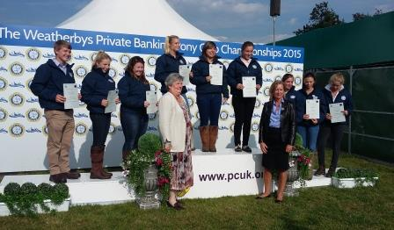

Also one of our very talented artists, Carolyn Dickson, had her art work of Asti and Dougal on display at the championships as part of the John King Young Artists Competition.

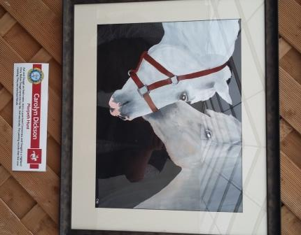

Tetrathlon Championships at Bishop Burton

Ewan Macaulay & Bethan Wyld represented our branch at the tetrathlon championships. Ewan was 10th in the open boys competition and rode on the England team which came 2nd in the international team competition. Both Ewan & Bethan did great clear rounds over a very demanding xc course.

