Ellen Valley Riding Club
Invite you to an evening with
Sir Mark Todd

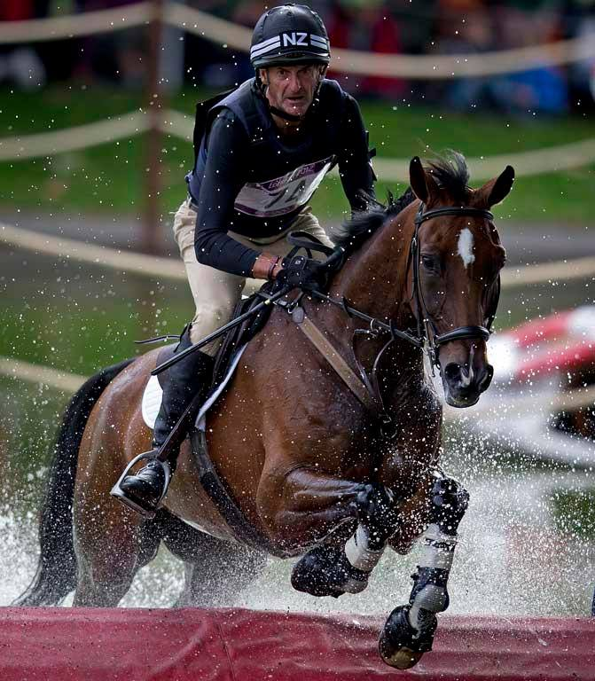

Tuesday 29 May 2018
At Greenlands Equestrian Centre
Doors open 5pm
Demonstration commences 7pm
This is a ticket only event
£30 per person/£25 EVRC members
Stalls, Food and Tipsy Filly Bar on site

For more information please see the
Ellen Valley website - ellenvalley.co.uk
or contact
Jodie 07530 157704 or Catherine 07833 209494
Join us for a great night!

