6th October 2020

Dear Tetrathlon Contact, DC, Secretary or Competitor

I am writing to let you know about the Scottish Tetrathlon Postal Shoot Competition. It is open to anyone and everyone with different team events and individual events, be you a Pony Club member or not – please join us and take part!

The Competitions are for anyone of any age; mums, dads, brothers, sisters, and friends. This year we will be running four virtual competitions to be shot over 16 weeks; November to February. The details of each competition are below and will be on our website.

Entries are being taken on line at https://clubentries.com/scottishtetrathlon/index.php and this year we will not be sending out targets, please use your own and then send me a photo of your target, or feel free to post me the original. I will send you stickers to put on the front of the target to help me with identification. Please organise entries now, as the entries close on 31st October 2020.

If you have any queries, or would like to know more about the competition, please send me an e-mail or give me a ring. Also, feel free to pass this on to anyone who might be interested in taking part.

Yours sincerely

Kate Farnsworth
On behalf of the Scottish Tetrathlon Committee
Mobile: 07766 761 330 Email: kate.farnsworth1@virgin.net

www.tetrathlon.org

(Original) Postal Shoot  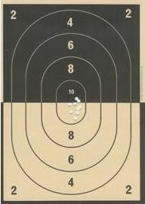 | The main Postal Shoot consists of 12 Pony Club targets to be shot over 16 weeks (November - February). The idea is to shoot and return three targets each month.  Ten rounds are shot on each target.  Competitors are divided up into divisions according to the range they shoot at and their previous or estimated scores.  Adults and Open competitors (15–21 years old on 1st Jan 2021) shoot  1 handed at 10m.  Junior competitors (12–14 years old on 1st Jan 2021) shoot 1 handed at 7m. Minimus competitors (8–11 years old on 1st Jan 2021) shoot 2 handed at 7m.  There are gold and silver medals for the winner and runner-up in each division and each age group. £14 per entry. Add in an entry to the Michael/Jeanie Jones Trophy and it only costs an extra £2! Entries by 31st October 2020.

Mitchell ‘Family’ Team  Trophy  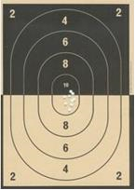 |  | The Mitchell ‘Family’ Team Competition involves a team of a minimum of 3 family members shooting.  Scores will be taken from original postal shoot targets submitted each month, so all team members must be entered in the original postal shoot competition.  Team is made up of a minimum of 3 (maximum of 4) family members, must be immediate family e.g. Parents, Aunties, Uncles, Grandparents and 1st Cousins.  Of the 3 targets submitted each month (from each team member) top 3 scores count for overall team score. Entry fee £7.50 per team.  Each team must include at least 1 PC member. Entries by 31st October 2020
Paula Gray Team  Trophy | Named after the founder of the shoot: The Paula Gray competition is a team event for Pony Club members shot on Pony Club Targets with scores taken from the Original Postal Shoot.  Teams are three members of the same Pony Club.  Each team must have a boy of any age and must comprise of:  - 1 Senior (Over 15 years as at 1st January 2021) shooting 10 metres with one hand  - 1 Junior (14 years and under as at 1st January 2021) shooting 7 metres with one hand  - 1 Minimus (11 years and under as at 1st January 2021) shooting at 7metres with two hands  More than one team per Club may be entered. All team members must return all 12 targets by end of Feb 2021. Entry Fee £7.50 per team. Entries by 31st October 2020

A Challenge - Michael and Jeanie Jones Trophy Competitions
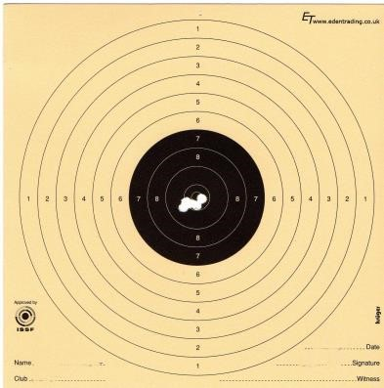
For members and non-members: shooting at ISSF/NRSA 10m Air Pistol targets – like those used in Modern Pentathlon.
Five rounds are shot on each of 12 Targets – making a total of 60. Three targets are to be shot and returned each month.
There are separate competitions for Members (competing for the
Jeanie Jones Trophy) and for non-members (competing for the Michael Jones Trophy).
There are classes in the Jeanie Jones competition for those who are over 15 and shooting at 10m, those 14 and under who shoot at 7m with one hand, and those who shoot at 7m with two hands. Entry fee £14 (£16 if you would like to include an entry to the Original Postal Shoot)
Entries by 31st October 2020.

Note:
- Age: Ages (and therefore competition classes) are ‘as at 1st January 2021’. Only PC members and those non-members under 21 need to enter a date of birth.

- Entry Fee: Entry fee is £14.00/person for the individual events. Should you wish to enter the Original Postal Shoot and Michael/Jeanie Jones trophy the total for both would be £16.00/person – two events for only £2 more!

- Entering: Entries can be made online at: Club Entries https://clubentries.com/scottishtetrathlon/

- Targets and Stickers. Please use your own targets with the stickers I send you. Put the sticker on the front and photograph the target with white paper behind, to help me see the shots!

- Submitting Targets Post is still very welcome. Please score the targets and email/whatsapp/messenger/post the scores and photo of the targets to me monthly.

Entries close on 31st October 2020

Final targets to be submitted by 28th February 2021, please do send them in as you shoot them to help me keep up with the paperwork!

Kate Farnsworth
Birklea
Harryburn Road
Lauder
TD2 6PB
Mob 07766 761 330
Email: kate.farnsworth1@virgin.net

