Dear Members, families, volunteers and staff,
The Pony Club is an International charity working within the guidelines currently provided to continue to keep our members, coaches, and volunteers safe. It is vitally important that we continue to follow and adhere to Government guidance. We must also be respectful of the differences in our areas, which can cross borders in some instances.
Today we can start to expand our training sessions from one to one to small groups in many areas of the country. As we step into Phase 3 of our Operational Plan in some areas, I wanted to share further advice and guidance.

Scotland and Wales - Phase 1 and 2
Only outdoor one to one coaching is permitted, and in Scotland, a coach can only meet one household a day. Horse Scotland and Sport Scotland are continuing to lobby hard to get this changed and offer more flexibility for coaches, we will update you as we know more.
- Government Advice for Scotland – Horse Scotland support, exercise guidance
- Government Advice for Wales – Outdoor exercise, livestock and equine owners advice, return to sport

England, Northern Ireland, Guernsey, Jersey and the Isle of Man - Phase 3
Your locality will determine what size of gathering you are permitted, but you must remember if it is a gathering of 6 people for example, this is 5 members and 1 coach, in a mounted or unmounted session. Pony Club activities may only take place outside, they are not permitted in indoor facilities.
- Government Advice for England – Resumption of outdoor sport and recreation, Guidance for personal trainers and coaches.
- Government Advice for Northern Ireland – Current guidelines

Things to Remember
- It is vital that social distancing of 2 metres is observed at all times.
- When travelling to a training session you must only be with a member of your household in an enclosed space.
- Upon arrival to a training session think about where you are parking and the proximity to others when moving around your vehicle with and without your horse.
- Please do not greet other members closer than 2 metres and do not congregate in groups larger than those allowed.
- If spectating because your child is being taught you will be included in the ‘gathering’ number if you are within the perimeter of the ridden arena, or similar space within a field. Observe the appropriate distance to ensure the safety of the coach, riders, and other spectators.
- You must abide by all venue rules, they have specific policies and procedures in place to ensure everyone’s safety, please follow these.
A branch or centre should complete our COVID-19 Risk Assessment, in addition to existing risk assessments. We must continue to limit risks to members, coaches, and volunteers as we resume activity.
The latest infographics for Phases 1, 2 and 3 of the Operational Plan and COVID-19 Risk Assessment can be downloaded here.
To read today’s advice from British Equestrian (BEF) please follow this link.
A useful reminder of the group gatherings can also be seen via the BBC’s latest infographic ‘UK rules on meeting up’, published online today.

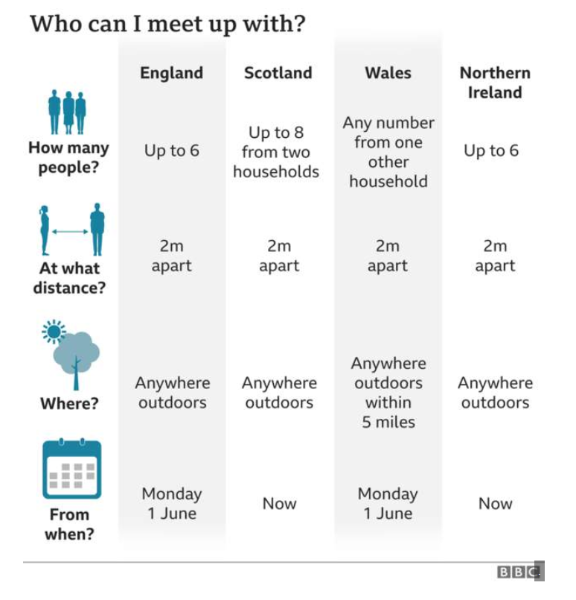

The Pony Club are currently focused on the safe resumption of group riding and rallies, we will of course inform you when we move to Phase 4 of the Operational Plan. Our sporting committees are currently assessing how best to support members as restrictions are lifted. However, it is important to remember that the facilities required for some sports may still be unavailable. For example, whilst horse racing is resuming behind closed doors it is not possible to arrange any racedays for our Pony Racing members until further restrictions are lifted.
Please continue to follow Government advice and be responsible for the safety of yourself and others around you. We all want to return to normality, but we are not there yet. We should be thankful for the opportunities we do have to enjoy training again.
Marcus
Marcus Capel
Interim CEO

