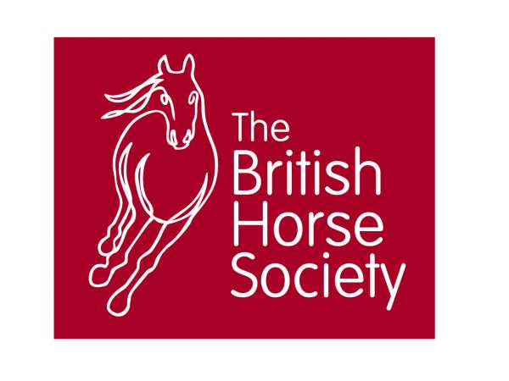

Would you like to gain some great coaching tips, be able to volunteer at your local branch or just enjoy an educational day with a top coach.

Approved Pony Club/BHS Instructor CPD sessions.

Earnest Dillon
FBHS/BE Master Coach –Eventing/ UKCC L3 SJ Coach/Accredited BS Coach

Thursday 2nd April 2020
10am – 4.00pm (half day option £20 – PC only)
Cost £40 (Riders £25 – 20 spaces)
Riders PC members plus 8 places for Instructors/Competition Riders
Venue: Newton Rigg EC, Penrith Cumbria. CA11 0AH
All enquires to Fiona.veitch@outlook.com CFHS Branch Secretary
Post all replies to Fiona Veitch, Agricola, Newbiggin, Penrith Cumbria CA11 0HT
These will be hour sessions, working with riders of all abilities. SJ exercises to help improve the scales of training, ride a course, gymnastic exercises to improve the way of going.
FOR THE BHS THE FULL DAY MUST BE ATTENDED
All payable to CFHS. Please write email on back of cheque as conformation will be sent via email. BACS 20-66-97 00307521 ref Ernest Dillon and email Fiona.veitch@outlook.com to confirm payment and book place.
Closing date for entries March 26th
Places will be allocated on a first come first served basis.
Senior PC Members very welcome.
We will plan to have soup and sandwiches to buy for lunch.
Coffee, tea and biscuits will be provided on arrival, to buy later
----------------------------------------------------------------------------------------------------

Pony Club/BHS approved CPD course – April 2nd Newton Rigg with Earnest Dillon

Name …………………………………………………………….
Contact details phone & email _______________________________________
Area …………. Branch/Centre …………………………………………
…………………………………………………………………………………………………………………….
…………………………………………………………………………………………………………………….

I enclose a cheque for £40 (£20 PC only)
(also £25 if rider – these must be emailed first to see if there is a space) payable to CFHS.
Post to Fiona Veitch, Agricola, Newbiggin, Penrith, Cumbria, CA11 0HT by October 16th 2019.

Or BACS 20-66-97 00307521
ref Earnest Dillon plus email to confirm Fiona.veitch@outlook.com

Information on the Day:
The CPD day will begin at 10am (or a half day if only PC). There will be coffee/Tea free on arrival.
There will be lessons taking place as you arrive so please be quiet as you enter the indoor arena. The Arena does not have heating in the seating area so come prepared.

Please also be aware that the riders are not just guinea pigs, so be concisions of your feedback and questions.

We have spaces for instructors to ride, if you would like to bring your horse for a lesson please get in touch with Fiona. (£40 include lesson and CPD)

Newton Rigg is situated 3 miles from J40 on the M6 and 4 miles outside the town of Penrith. On arrival take the second entrance onto the Campus, then the first left to the indoor arena. CA10 1AH

